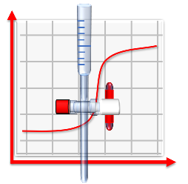**OpenTitration V1. User Manual**

**Daniel Levenson 2020©**

**January 20, 2021**

**Getting Started:**

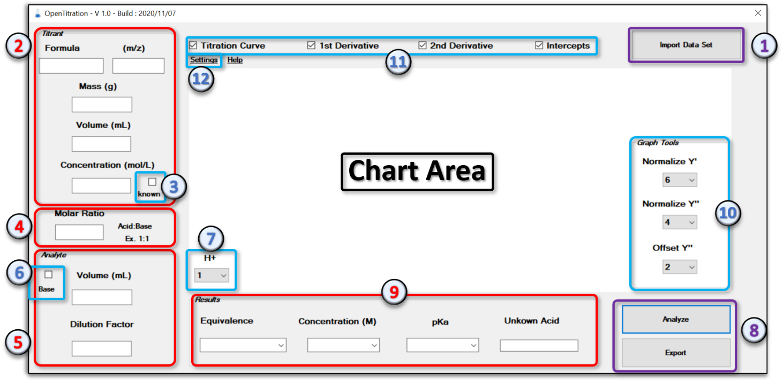

**Table of Contents:**

1. **Import Data**
2. **Titrant Information**
3. **Known Concentration Toggle Switch**
4. **Molar Ratio Entry**
5. **Analyte Information**
6. **Base Analysis Toggle Switch**
7. **Protonation State Selector**
8. **Analyze/Export**
9. **Results**
10. **Graphing Tools**
11. **Chart Series Controls**
12. **Settings**



**Read the import data section before getting started.**

1. **Import Data**

Imported data needs to be in the correct file format to be properly utilized by the program. That is a comma separated file, where **(volume(mL), PH)**. Each data entry needs to be on its own separate line (**figure 1**) and saved into a text file (.txt) using the windows notepad text editor.

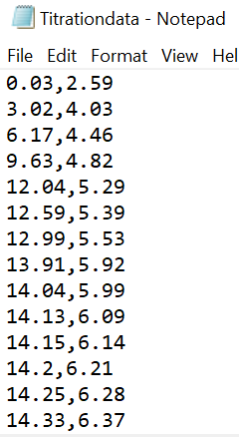

**Figure 1**. Data compiled in the proper file format

Data can be automatically compiled into the proper format using excel. Simply input your data into the cells as illustrated (**figure 2**), where volumes are in the ‘A’ column and PH values are in the ‘B’ column. Do not include text labels for volume and PH in the respective rows as this will be rejected by the import wizard. Save the files as a comma separated file (.csv) and your data is ready to be opened by the application (**figure 3**).

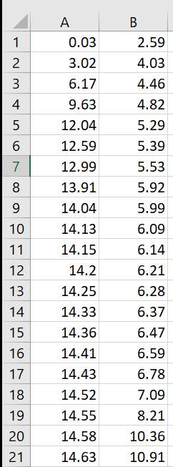

**Figure 2.** Data format in excel

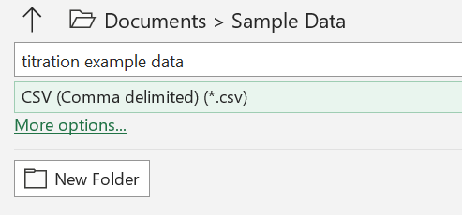

**Figure 3.** Correct file type to save titration data

Once your data is ready to be analyzed, press the import button and a prompt will open allowing you to select your data. By default, the file window looks for text files, but this file type can be changed if your data is in a (.csv) file. If you have done everything correctly your titration curve should be plotted on the chart window.

1. **Titrant Information**

The titrant is the component in a titration that has a known concentration and is used to determine the equivalence point and molarity of the unknown solution. The formula entry will automatically compute the molar mass of the compound (**figure 4**). Currently brackets and chemical abbreviations for compounds are not supported.

To determine the molar concentration of your solution simply put in the mass and volume in addition to the formula. Pressing the analysis button will automatically compute the concentration. There is no need to manually compute the concentration, as this field will automatically be overwritten with the computation from the previous entries.

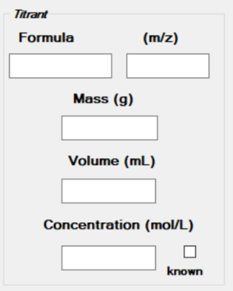

**Figure 4.** Titrant controls and inputs

1. **Known Concentration Toggle Switch**

The known checkbox can be selected if the concentration of the titrant is already known. The mass and the volume will be omitted from the calculation, and their entry boxes will be closed to any data entry (**figure 5**). The mass of an inputted formula can be added optionally if that information is important to your export file.

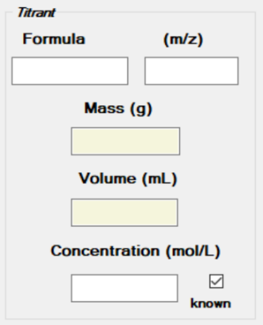

**Figure 5.** Titrant controls with known concentration selected

1. **Molar Ratio Entry**

This field can be left blank as a 1:1 ratio will be added automatically. If you are dealing with a titration that requires a different ratio a particular format is required. That is the number of acid moles with a semicolon in between the number of base moles. Of example if you have 2 moles of acid (as in the case of H2SO4) to your base analyte your entry would be ‘**2:1**’.

1. **Analyte Information**

As is often the case, the analyte is often diluted so multiple titrations can be performed on the same sample. To account for this simply put in the number of times your sample was diluted in the dilution factor field (**figure 6**). If no entry is done a default dilution factor of 1 is assigned to this field. To determine the overall concentration of the solution the volume of the analyte must be inputted into the volume field.

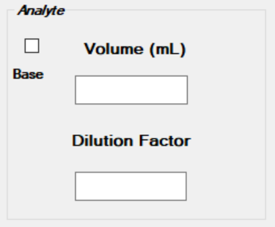

**Figure 6:** Analyte information fields

1. **Base Analysis Toggle Switch**

By default, the application is set to analyze a solution with a basic titrant and acidic analyte. If the analysis is being done on a basic analyte, then the base checkbox must be selected. This application computes the equivalence point based on the derivative calculated from the data. An acid will abruptly increase when an equivalence is reached meaning there is a global maximum that can be obtained. A base analyte will decrease rapidly when approaching equivalency meaning a global minimum must be obtained. An incorrect selection will prevent this application from computing the value correctly.

1. **Protonation State Selector**

To accurately determine the unknown analyte and equivalences the correct protonation setting must be applied. Protonation states of the unknown are not automatically determined, and the largest peaks will ultimately be used for the calculations if the wrong setting is applied (**figure 7**). This selector must be used on acid analytes as well.

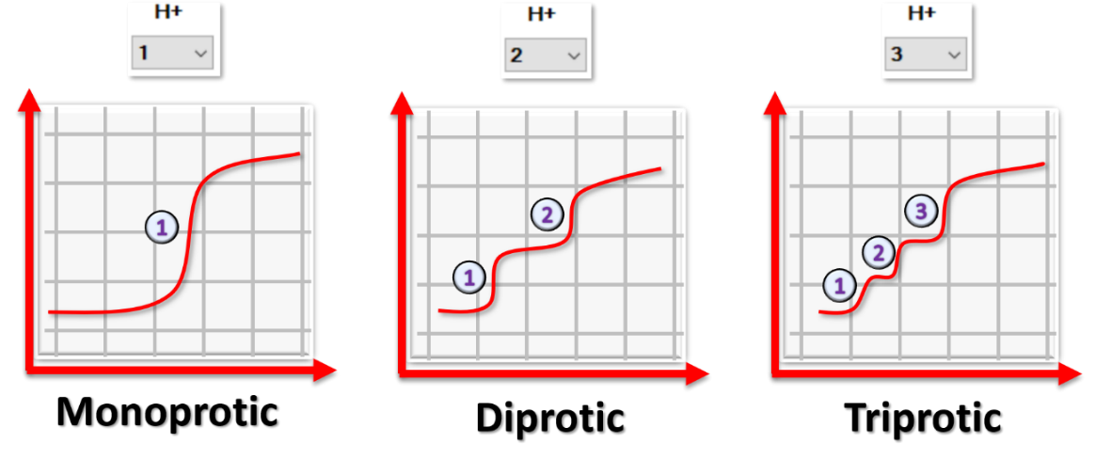

**Figure 7.** Demonstration of different titration curves and recommended settings

1. **Analyze/Export**

The analysis button uses all the settings and data input and initiates the computations on that information. The export button then allows you to output that information in three different file formats: 1) Text File (*.txt), 2) PDF (*.pdf) 3) Graphic Image (*.png). The PDF option outputs both the graph and all the compiled information into a single report. If you wish to manually compile the report, all computed information is more easily copied from the text file option. The graph itself can be exported separately to all the information by selecting the graphic image option.

1. **Results**

Results are tabulated upon use of the analyze button. Using the computed pKa data the unknown acid or base is determined from a library of acids and known pKa values. For bases the determined pKb values are converted to pKa values to be compared. The percentage match of also calculated to show how close your result is the actual value (**figure 8**). Multiple values for mono and diprotic analytes are logged into the combo boxes and are automatically output when the data is exported.

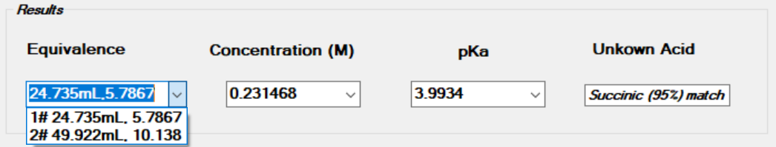

**Figure 8**. Tabulated results of a diprotic acid analysis

1. **Graphing Tools**

Graphing tools pertain to the visual presentation of the derivative and second derivative series on the graph. For a more convenient data visualization these series are normalized (**equation 1.**) before being plotted on the chart. The output values for the first and second derivatives are the values without normalization.

**Equation 1: $z_{i}= \frac{x_{i}-min⁡(x)}{\max\left(x\right)-min⁡(x)}$**

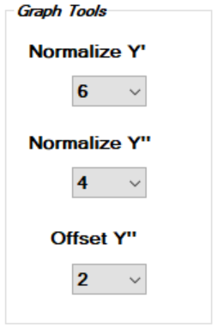

**Figure 9:** Graphing Tools

The normalized values are then multiplied by a factor. The default factor is 6 for Y’ (zi*6) and 4 for Y’’ (zi*4). This is simply to increase the size observed on the graph.

Due to the second derivative having a negative component an offset value is applied to keep it within the confines between 0-14 for the PH scale. This adds the selected value to every normalized value (zi + offset).

1. **Chart Series Controls**

You may not want to include the derivative and second derivative chart series on your graphs. You can remove these from the chart simply by toggling off the switch. The exported graphs will look exactly how they appear before they are exported.

1. **Settings**

A wide array of text and chart options can be changed using the settings. There are also settings that allow you to change the font, size, margin and spacing options in the exported PDF files (figure 10). If you wish to preview these settings changes simply hit the apply button. If you found settings that you wish to apply to all data going forward hit the save button. All these settings will be automatically input whenever you reopen the application when the save button is applied. If you wish to return to the default buttons, simply hit the reset button.

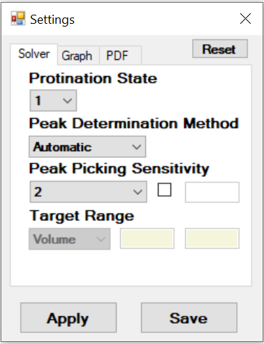

**Figure 10.** Settings toolbox

There are two types of solve methods available, ‘automatic’ and ‘manual range’. Each has settings that can be adjusted for your data analysis needs.

**Automatic:**

Peak picking sensitivity is feature unique within the settings toolbox. There may be instances where the default settings will not find the peaks properly. The algorithm works by finding the largest peak in the derivative graph and computing the equivalence points from that. When you have multiple peaks due to multiple equivalence points the program first computes the largest peak, and then zeroes those values in a temporary derivative series (**figure 11**). The application then looks at the next global maximum and does the next set of computations based on that value. The peak picking sensitivity allows you to choose the number of values removed before and after the initial global maximum. This can be handy if there are many data points, or not a lot of data points in your titration curve. If you feel that the available range of peak picking selectivity is too small for your data set, you can check the box beside the selector to input your own custom peak picking selectivity.

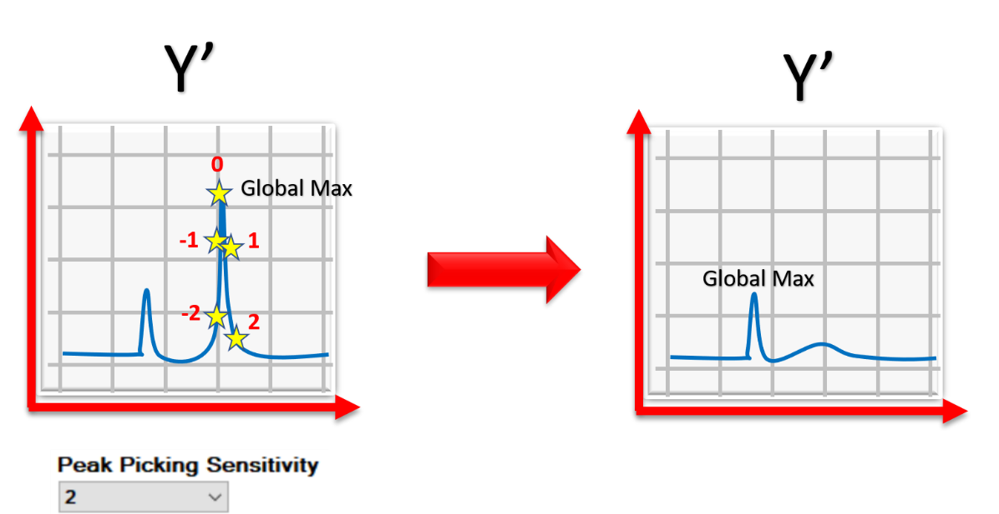

**Figure 11.** Illustration of peak picking algorithm with a sensitivity value of 2

**Manual Range:**

It is possible that the automatic peak picking option will not be sufficient for your analysis. For example, if there is a large difference in the size of the peaks, the automatic option will not be sufficient to capture it. In this case it will be prudent to select the ‘Manual Range’ option in the solver. To use this option, you will need to have more then one peak that you are trying to process. Simply select the ‘Manual Range’ option and input a value or values that are in between the two peaks. This can be done for both pH and volume. The solver will break both the graph into the sections between the value(s) that were selected (**figure 12.**)

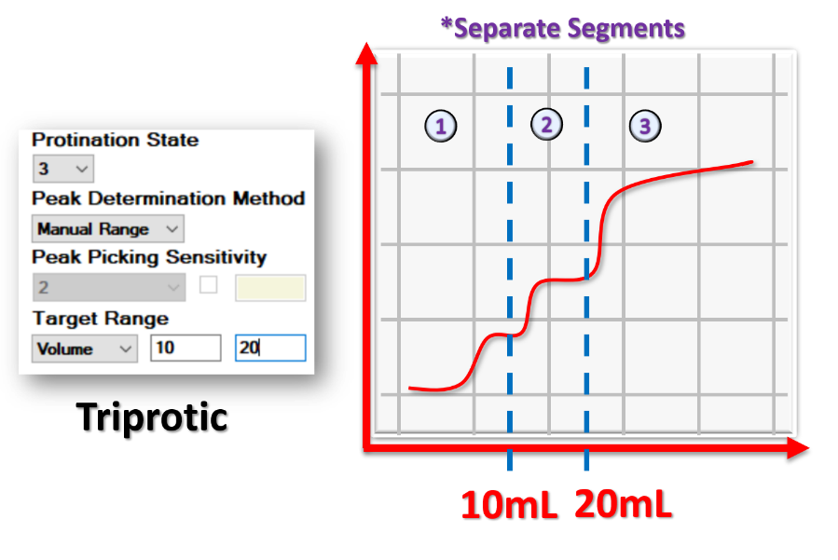

**Figure 12.** Manual Entry Example for Triprotic Acid